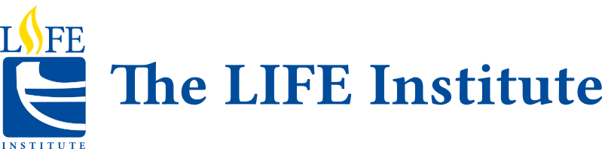
Philosophy: Social and Political Issues
TOPICS:
WEEK #1
Introduction to Social/Political Philosophy and Reasoning and Argumentation.
Information Constraints, What is an Argument? Biases: Biological and Cultural. Scientific Reasoning.
Ethical Reasoning. This class will introduce the basics of Critical Thinking, Ethical Reasoning, and Scientific Reasoning so that students will be better equipped to comprehend and discuss the various social and political issues that follow.

WEEK #2
Creationism vs. Evolution. In this class, we will look at the classic debate between science and religion over the existence of God, the origins of humans, and some of the classic debates that have taken place over the years e.g. Bishop Wilberforce vs. Thomas Huxley.

WEEK #3
Justice, Crime, and Punishment:
The Violent Brain, the State vs. the Individual, the Future of Law and Ethics. In this class, we will consider how recent developments in science – particularly brain science – have given us reason to re-visit how we view criminal intent, culpability, and even guilt or innocence. We will also look at prison systems in Canada and the US to examine alleged inequities existing in these penal systems.

WEEK #4
Abortion: We will examine the history of abortion in Canada and the US and consider the legal, moral, and social aspects of this issue. We will consider to what degree the US is poised to overthrow Roe v. Wade and whether or not such a turn of events could happen in Canada.
Euthanasia: We will look at the history of ‘mercy killing’ throughout the world but especially in Canada. We will also consider how Medical Assistance in Dying (MAID) developed in Canada.

WEEK #5
Biotechnology: Students will gain an appreciation for how science, business, government, and society drive the development of biotechnology products. Topics will include stem cells and regenerative medicine, diagnostics, cancer therapy, biotechnology in the developing world, antibiotic alternatives, etc.

WEEK #6
WEEW
Environmental Issues: Is climate change real? How do we know? What is the evidence? Who still believes it’s not happening? And why? We will delve into both sides of this issue to consider arguments for both sides.
Genetic Engineering: To what degree should we manipulate our own DNA to combat diseases? With technologies such as CRISPR-Cas9, we can literally cut and paste defective DNA with ‘healthy DNA and, in so doing, eliminate certain types of disease. But should we? Why? Or why not?

WEEK #7
WEE
Artificial Intelligence: What happens if Artificial Intelligence (AI) becomes sentient, or conscious? Does it become ‘alive’ in similar ways to humans or other animals? And if so, does it have rights? How will we treat such life forms in the future? And what new ethical issues will this present?

WEEK #8
Misinformation, Disinformation, and Conspiracy Theories: What’s the difference between information, misinformation, and disinformation? And how do these different forms lead people to believe in – sometimes bizarre – conspiracy theories? We will carefully consider how we can empower ourselves in knowing how to ‘check the reliability’ of such information and apply our critical thinking skills as a defense against being duped.

Students will become more familiar with the ideas of some of the greatest social and political issues of our time and throughout history. They will become more empowered to have meaningful discussions about perennial topics such as the nature of politics, the existence of God, environmental issues, biotechnology, AI, and the dilemmas of ethics. As well, students will develop a greater appreciation of philosophy as they learn how it relates to their own personal lives.

This course provides an introduction to various social and political issues in society. We will examine some of the most controversial and interesting topics in society today including (but not limited to) Evolution, Religion, Crime, Environmental Issues, Politics, and Science and Technology. We will also examine what ethical elements are involved in regards to our personal views on such topics.

Dr. Christopher DiCarlo is a philosopher, educator, and author. He is a past Visiting Research Scholar at Harvard University. Dr. DiCarlo has won several awards including TV Ontario’s Big Ideas Best Lecturer in Ontario Award and Canada’s Humanist of the Year.

